This section is not accurate, or properly filled out.

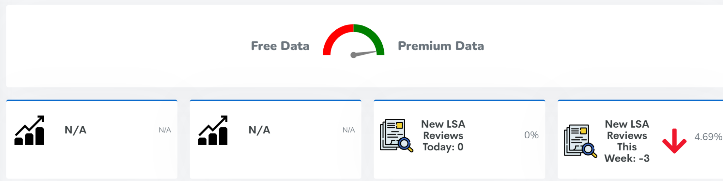

It should tell us today’s average rank, and weekly average rank

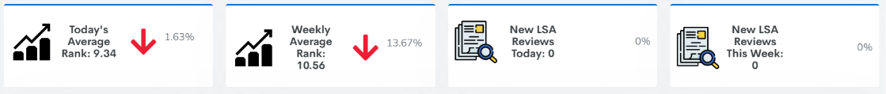

Same data is missing on reports.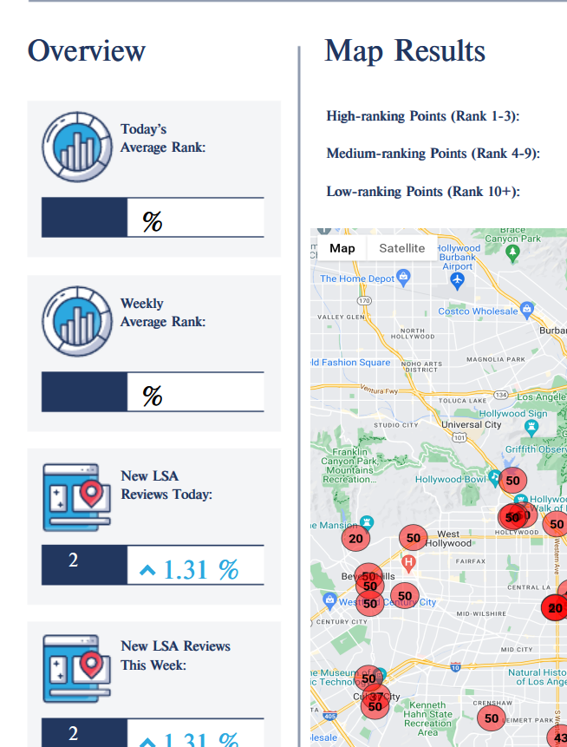

New Feature: New Competitor in LSA Market

We want to email our clients an alert anytime a new competitor is added to their LSA Marketplace for their keyword.

I can send you the HTML for the email

New Feature: Changing LSA Keywords to LSA Category/Area

Example: Garage Door Repair has about 11 keywords, Personal Injury lawyer has about 20 keywords

Rather than users adding keywords, they can add categories which have pre-populated keywords that will run automatically for them. We’ll have to add tabs, and the reports will be much larger.